**Project Planning Phase**

**Project Planning Template (Product Backlog, Sprint Planning, Stories, Story points)**

|  |  |
| --- | --- |
| Date | 26 June 2025 |
| Team ID | LTVIP2025TMID59438 |
| Project Name | Shopsmart: your digital grocery store experience |
| Maximum Marks | 5 Marks |

**Product Backlog, Sprint Schedule, and Estimation (4 Marks)**

Use the below template to create product backlog and sprint schedule

|  |  |  |  |  |  |  |
| --- | --- | --- | --- | --- | --- | --- |
| **Sprint** | **Functional**  **Requirement (Epic)** | **User Story**  **Number** | **User Story / Task** | **Story Points** | **Priority** | **Team**  **Members** |
| Sprint-1 | User Authentication (Login, Registration) | USN-1 | As a user, I can register using my email and password so I can create an account. | 2 | High | Dev Team |
| Sprint-1 |  | USN-2 | As a user, I can log in securely so I can access personalized features. | 3 | High | Dev Team |
| Sprint-1 |  | USN-3 | As a user, I can log out to protect my account. | 3 | High | Dev Team |
| Sprint-1 | Profile Management | USN-4 | As a user, I can view and update my profile details (name, email). | 3 | High | Dev Team |
| Sprint-2 | Product Listings and Search | USN-5 | As a user, I can search for products by name or category so I can find items quickly. | 4 | High | Dev Team |
| Sprint-2 |  | USN-6 | As a user, I can filter and sort products by price or rating so I can make informed decisions. | 4 | High | Dev Team |
| Sprint-2 | Order Workflow (Cart, Checkout) | USN-7 | As a user, I can add products to my shopping cart so I can purchase them later. | 4 | High | Dev Team |
| Sprint-2 |  | USN-8 | As a user, I can view and update my cart (change quantity or remove items). | 4 | High | Dev Team |
| Sprint-2 |  | USN-9 | As a user, I can proceed to checkout and place an order. | 4 | High | Dev Team |
| Sprint-2 | Feedback and Contact Features | USN-10 | As a user, I can view my past orders so I can track purchases. | 3 | High | Dev Team |
| Sprint-2 | Admin Panel (Basic View & Controls) | USN-11 | As an admin, I can see all customer orders to manage order fulfillment. | 4 | High | Dev Team |
| Sprint-2 | Feedback and Contact Features | USN-12 | As an admin, I can add new products to the catalog so I can keep the store updated. | 3 | Medium | Dev Team |
| Sprint-1 | Product Management (Add/Edit/Delete) | USN-13 | As an admin, I can edit or delete existing products so I can manage inventory. | 4 | High | Dev Team |
| Sprint-2 | Admin Panel (Basic View & Controls) | USN-14 | As an admin, I can generate a report of top-selling products to analyze performance. | 4 | High | Dev Team |
| Sprint-1 | Basic UI for Login and Product Pages | USN-15 | As a user, I can see product images and details so I can make informed buying decisions. | 3 | Medium | Dev Team |
| Sprint-2 |  | USN-16 | As a user, I want the app to be responsive and fast-loading for a smooth experience. | 3 | High | Dev Team |

**Project Tracker, Velocity & Burndown Chart: (4 Marks)**

|  |  |  |  |  |  |  |
| --- | --- | --- | --- | --- | --- | --- |
| **Sprint** | **Total Story Points** | **Duration** | **Sprint Start Date** | **Sprint End Date (Planned)** | **Story Points**  **Completed (as on**  **Planned End Date)** | **Sprint Release Date (Actual)** |
| Sprint-1 | 23 | 4 Days | 17 June 2025 | 20 June 2025 | 23 | 20 June 2025 |
| Sprint-2 | 33 | 5 Days | 21 June 2025 | 25 June 2025 | 33 | 25 June 2025 |

**Velocity:**

Imagine we have a 10-day sprint duration, and the velocity of the team is 20 (points per sprint). Let’s calculate the team’s average velocity (AV) per iteration unit (story points per day)

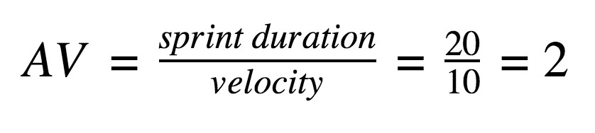

**Burndown Chart:** A burn down chart is a graphical representation of work left to do versus time. It is often used in agile [software development](https://www.visual-paradigm.com/scrum/what-is-agile-software-development/) methodologies such as [Scrum.](https://www.visual-paradigm.com/scrum/scrum-in-3-minutes/) However, burn down charts can be applied to any project containing measurable progress over time.

